CS3402 Tutorial 2:

1. Translate the ER diagram below to relational tables in the following steps.
2. Map *strong entity* type into relation
3. Map *weak entity + identifying relationship* type into relation
4. Map binary *1:1 relationship* types into attributes
5. Map binary *1:N Relationship* types into attributes
6. Map binary *M:N relationship* type into relation
7. Map *N-ary* relationship type into relation
8. Map *multi-valued* attribute into relation

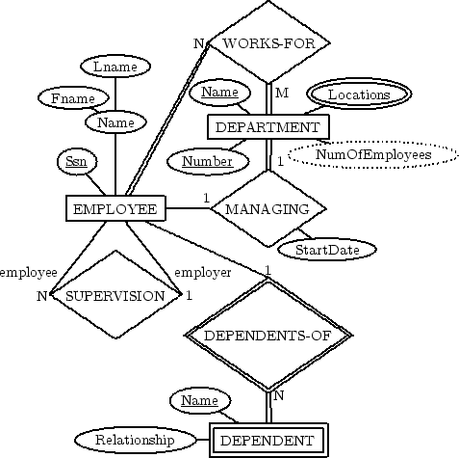

CS3402 Tutorial 2:

1. **Answer**:
2. Map *strong entity* type into relation
   * Include simple (or atomic) attributes of the entity
   * Include components of composite attributes
   * Identify the primary key from the attributes
   * Don’t include: non-simple component of composite attributes, derived attributes, multi-valued attributes (not yet)

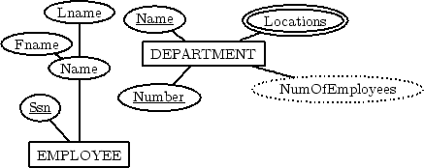

**EMPLOYEE (SSN, Fname, Lname,)**

**DEPARTMENT (Number , Name)**

1. Map *weak entity + identifying relationship* type into relation
   * Include simple (or atomic) attributes
   * Add the associated strong entity’s primary key as attributes (also known as *foreign key* because it refers to another relation’s primary key)
   * Set the primary key as the combination of the primary key of the associated strong entity and the partial key of the weak entity

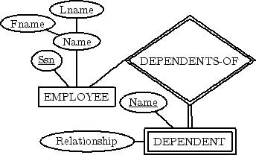

**DEPENDENT (Name, EmployeeSSN,** Relationship**)**

1. Map binary *1:1 relationship* types into attributes

* Include the primary keys of one entity type as attributes (foreign keys) of the other entity type (*note:* it is better to choose the entity in total participation to include the other entity’s key as attribute)
* Include also the simple attributes of the relationship type

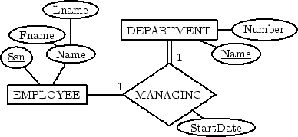

**DEPARTMENT** (**Number, Name**, **ManagerSSN, StartDate**)

1. Map binary *1:N Relationship* types into attributes
   * In the relation representing the *N-side* entity type, add the primary keys of the *1-side* entity type as attributes (foreign key)
   * Include also the simple attributes of the relationship type

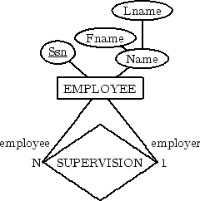

**EMPLOYEE** (**SSN, Fname, Lname**, **SupervisorSSN**)

1. Map binary *M:N relationship* type into relation
   * Include the primary keys of the participating entity types as attributes (foreign key)
   * Identify the primary key as the combination of the above foreign keys
   * Include the simple attributes of the relationship type

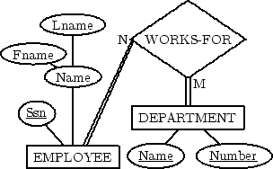

**WORKSFOR (EmployeeSSN, DeptNum)**

1. Map *N-ary* relationship type into relation
   * Similar to binary *M:N* relationship type
2. Map m*ulti-valued* attribute into relation
   * Include the given attribute
   * Include the primary attributes of the entity/relationship type owning the multivalued attribute
   * Set the primary key to be the combination of foreign key and its original attribute

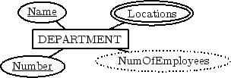

**DEPTLOCATION(DeptNum, Location)**

To summarize, the ER model will be translated into the following relational tables:

**DEPARTMENT (Number, Name, ManagerSSN, StartDate)**

**DEPTLOCATION(DeptNum, Location)**

**EMPLOYEE (SSN, Fname, Lname, SupervisorSSN)**

**DEPENDENT (Name, EmployeeSSN, Relationship)**

**WORKSFOR (EmployeeSSN, DeptNum)**